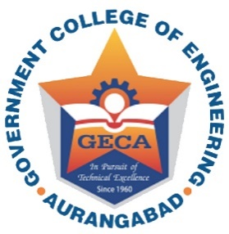 | Government College of Engineering, Aurangabad  ‘In Pursuit of Global Competitiveness’

Welcome Address - First Year Engineering students(2016-2017)
8th August 2016

Location: Annex Building, Applied Mechanics Department, Ground Floor
Hall No. D - 3

Time :11.30 am to 1.00 pm | Civil Engineering,  Mechanical Engineering  Electrical Engineering
Time :1.30 pm to 3.00 pm | E & TC Engineering  Computer Science and Engineering  Information Technology

